**Record of Ex. No: 4 –Projection of Solids - 2**

**Date of experiment:** 31.05.2021 **Date of submission:** 31**.05**.2021

**Name:** Kunal Keshan S **Department:** ECE – A **Roll No:** RA2011004010051

**Aim:**

To learn and understand projection of solids.

**Software used:** AutoCAD.

**Procedure:**

|  |  |
| --- | --- |
| Commands Used | Purpose of Command |
| UNITS | To set the units of the drawings. |
| LIMITS | To set the limits of the drawing area. |
| ZOOM | To adjust the view of the drawing area. |
| LINE | Used to draw a line. |
| POINT | Used to place a point on the drawing area. |
| TEXT | Used to add text in the drawing area. |
| TEXTEDIT | Used to edit any existing text. |
| DIMLINEAR | Used to add linear dimensions. |
| DIMALIGNED | Used to add aligned dimensions (i.e parallel to a line or point that is not perpendicular) |
| DIMANGLE | Used to add dimensions between any two lines or arcs. |
| DDPTYPE | Used to set the type of point and its size. |
| POLYGON | Used to draw a polygon of required number of sides, either inscribed in a circle or the circle in the polygon. Or the polygon can be drawn with respect to its edge length. |
| TRIM | Used to trim off unnecessary parts of the drawing. |
| BOX | Used to draw 3D objects. |
| EXTRUDE | To extrude objects which cannot be make with box. |
| SPHERE | To draw a 3D sphere. |
| CONE | To draw a 3D cone. |
| PYRAMID | To draw a 3D pyramid. |

**Steps:**

1. Adjust the right units and limits of the drawing area using UNITS AND LIMITS.
2. On the bottom right, select the settings icon and select 3D Modelling.
3. Use the BOX command to draw the solid object or simply click on the box option on the top left corner in home tab.
4. For Polygons, use the POLYGON command to draw one and then use the EXTRUDE command to add height to the polygon.
5. After adjusting the views of the objects, on the top right corner of the home tab click on views and click on the bottom right arrow to make sure that the projection is in first angle.
6. Then click on the view option again, select base and select from modal space to project the top, front and side view of the solid objects.

**Question 1:**

Draw the projections of the cylinder diameter 50 mm and axis length 80 mm when it is lying on the ground with its axis inclined at 45o to the wall and parallel to the ground. Draw its top, front and isometric views.

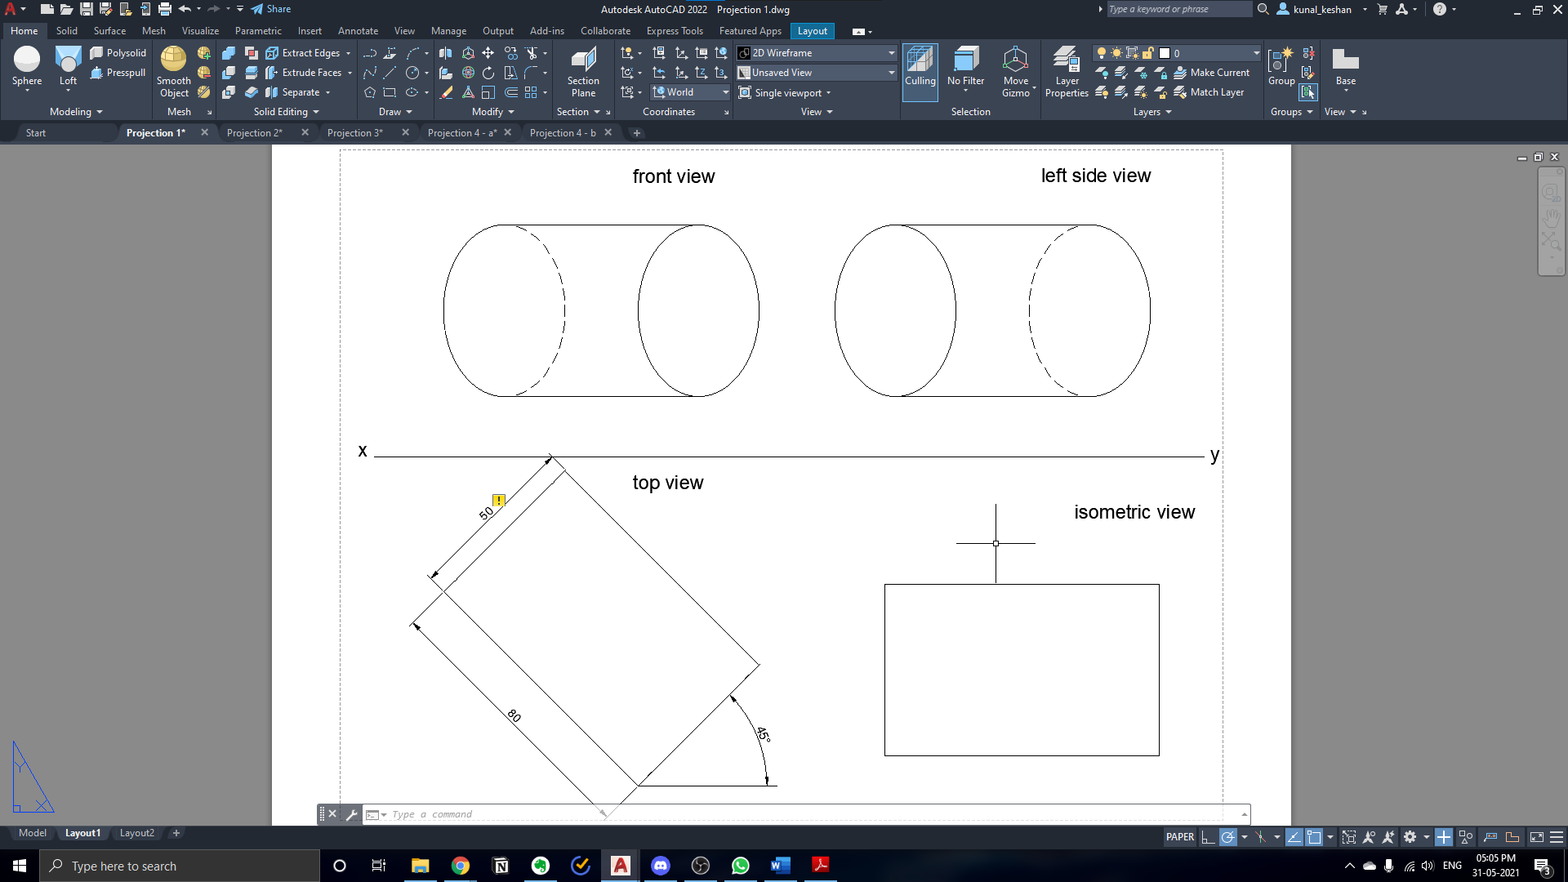

**Question 2:**

Draw the front, top and right side views of a cone of base diameter 40 mm and altitude 45 mm when its base kept parallel to the wall.

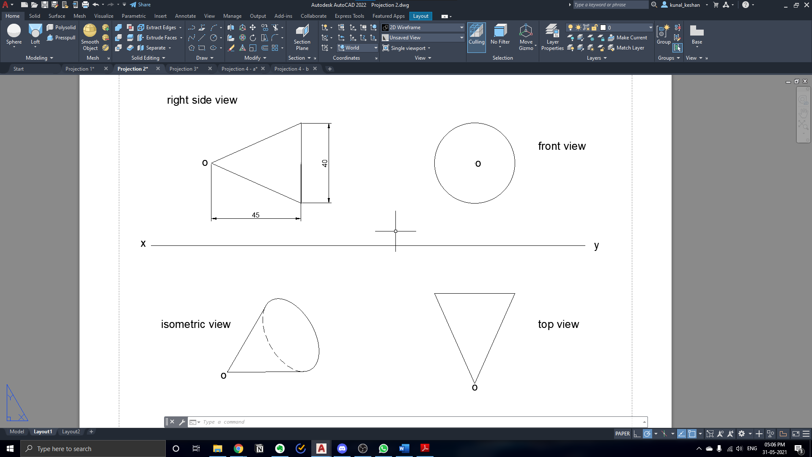

**Questions 3:**

A pentagonal pyramid of base edge 25 mm and axis length 60 mm rests on one of its base edges on ground such that the highest base corner 20 mm above ground. Its axis is parallel to the wall. Draw its top, front and isometric views

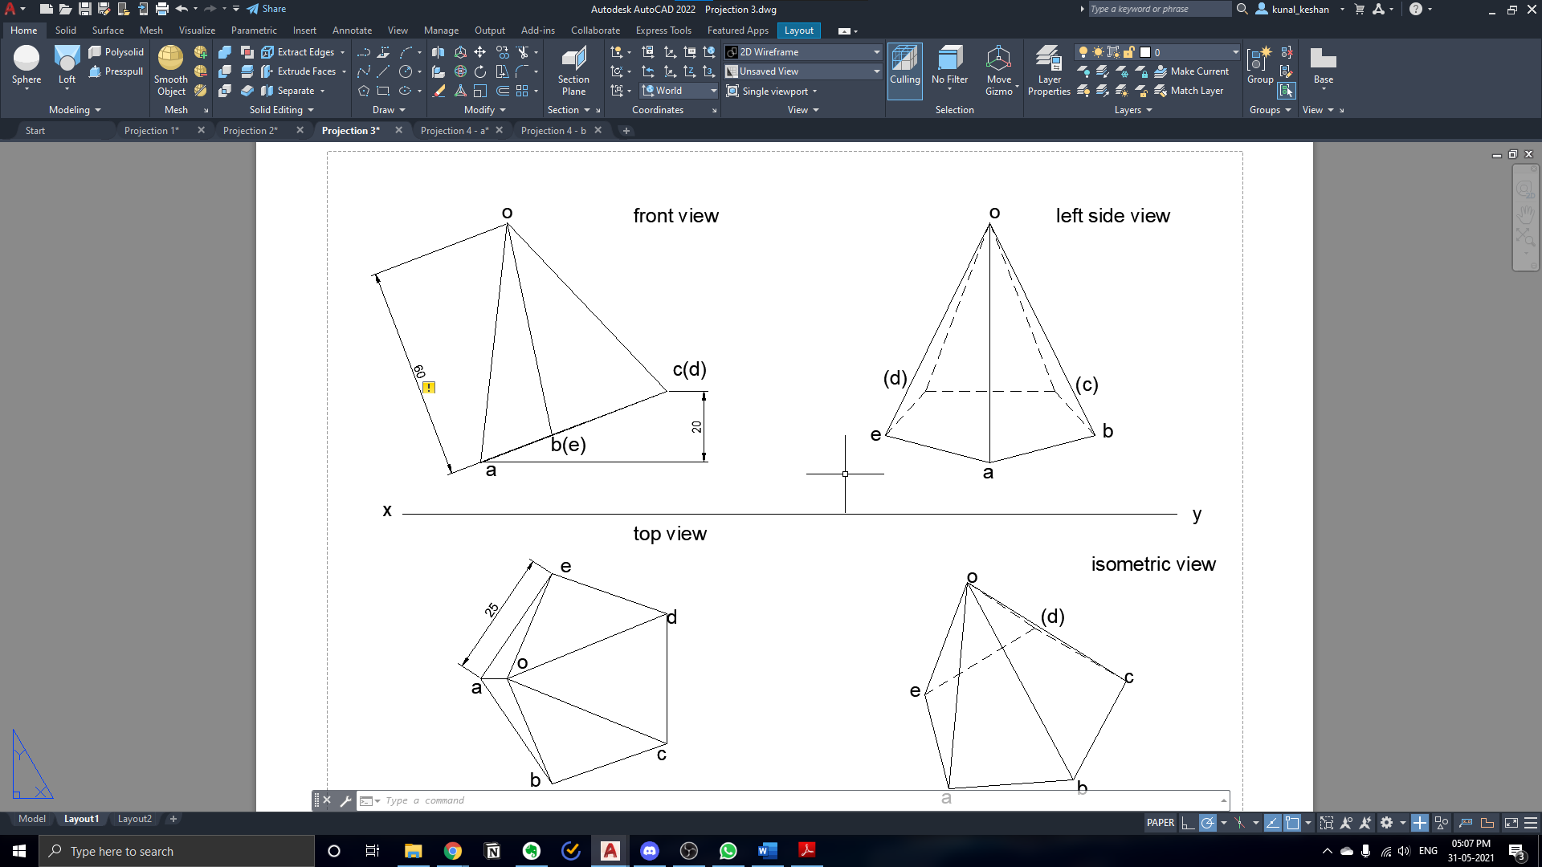

**Questions 4:**

Two equal spheres of diameter 30 mm resting on the ground touching each other. Draw their projections when i) the line joining their centers is parallel to the both the wall and the floor. ii) The line of the centers is parallel to the floor and inclined at 300 to the wall

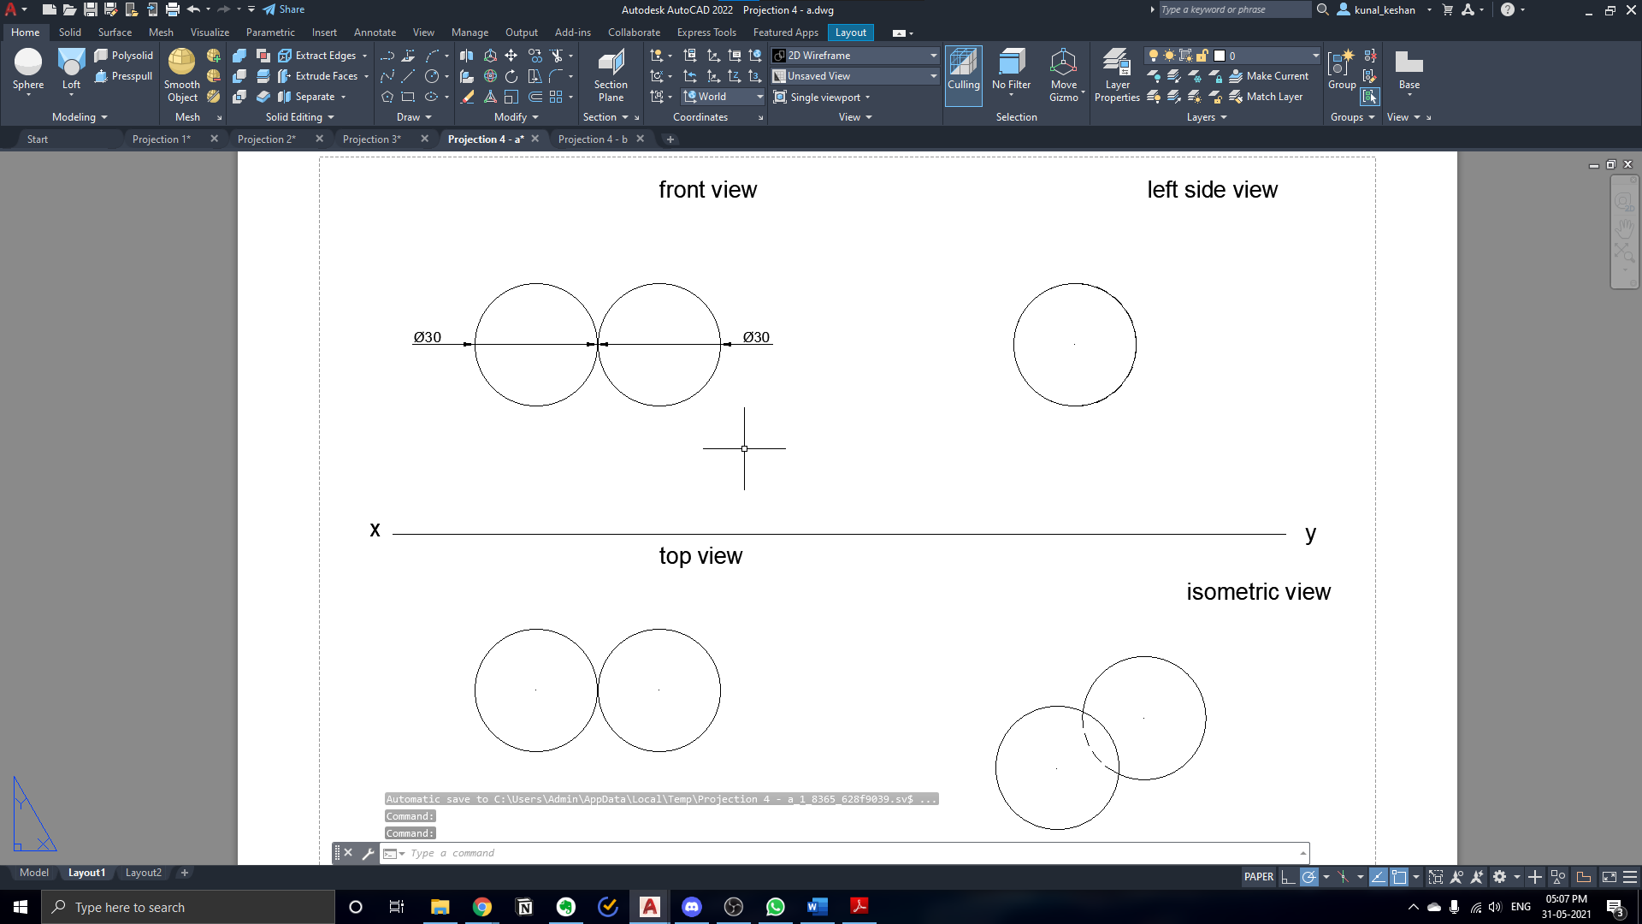

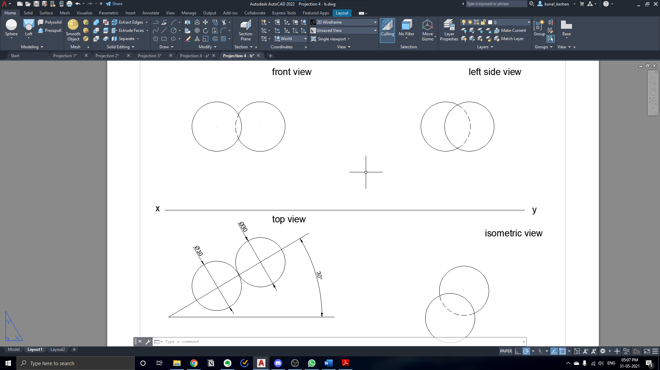

**Result:**

The projection of solids has been drawn with the required dimensions.